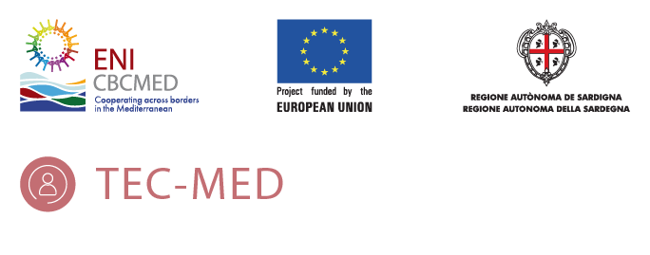

COMMUNICATION AND DISSEMINATION ACTIVITIES: INSTRUCTIONS
(APRIL 2021)

PP4 – GREECE

- INTRODUCTION
The aim of this guideline is to provide partners- all partners in the project are involved in the communication WP- with handy and practical instructions on how to contribute to the communication and dissemination objectives of the TEC-MED project.
This guideline will be very helpful to the monthly communication tasks every partner of the consortium will have to do. In order to ensure the highest effectively of this activity the LB and the WP2 leader (PP1) will be always available to help to the partners with the tasks required.
This document is in line with the TEC-MED communication plan and is according to the ENI CBC MED Programme – Indicative Information and Communication Plan 2016- and the Project Implementation Manual (PIM), section 10: Communication and Visibility.
The tasks required in this guideline are based on the following instructions:
- Develop relevant content taking into account the goals of the communication plan.
- Contribute monthly with interested information about the project and its results.
- Help the LB and the WP2 leader (PP1) to promote the project using the skills and the tools necessary to achieve the communication and dissemination objectives.

This guideline includes a Communication and Dissemination Activities Template (CDAT) as a practical and useful tool which it will be used in our communication monthly job. The CDAT have been developed by the LB and PP1 –as specific leader of the communication WP- in order to facilitate and improve a bidirectional channel between the consortium and the LB. This template follows the procedure -control chain- to govern the different communication activities indicated in the communication plan.
The CDAT will be completed every month and sent – during last week of the month (deadline last day of the month)-for each partner to the LB and PP1. The information sent will be reviewed by the communication team and planned to be published in the coming months.
What kind of subjects will be requested to be included in the CDAT (or subjects suggested by every partner)?

- About the actuality of the project.
- About research, papers, informs that are being developed in the project and can be published.
- About news related to the project and can be interesting for the general and specific audiences.
- About experiences, human stories related to or linked with the project.
- About activities where the partners participate directly (congress, meeting…) related to the project and its results.
- About initiatives or activities which the partners are in collaboration with and related to the project.
What kind of information needs to be sent in the CDAT?
- Relevant content coming from the partners to update the TEC-MED website and the social media channels, such as interviews, articles.
- Visual: pictures, video, infographic images… all kind of visual content to accompany the information.
- Information developed by the partners or by official fonts (Always indicate the author of the information and the author of the visual content).
The contents will be sent to the LB and the communication package leader in the following formats: articles in Word or editable document, Photographs in jpg, Interviews in .MP4 format.
The activities developed will contribute to the effective communication of the project and its results. These activities will continue throughout all the entire lifetime of the project.
SUMMARY OF GENERAL INSTRUCTIONS TO BE FOLLOWED
- The contents that the partners must prepare, write and elaborate will be proposed by the LB and the WP2 leader at the beginning of each month (first week).
- The partners will send all the required information at the end of each month, the deadline being the last day of the month.
- All content submitted must be in English and accompanied by photographs if required (at least one or two photographs) of their own or banks of free photographs without copyright, in the case of articles.
- This communication activity –publication of contents on website and on social medial channels- will continue throughout all the entire lifetime of the project.
- Partners can contribute a SUGGESTED CONTENT, but in no case it will replace the rest of the required activities.

REQUERIMENT (1): ARTICLE ABOUT VACCINE PROCESS IN YOUR COUNTRY.

Objective: Elaborate an article about the vaccine process against COVID-19 in your country. The idea is to tell how organized the process is and how it is at this moment. Is it working well or not?

The sudden appearance and spread of the pandemic of Covid-19 in Greece as in many other countries has deeply affected everyday life. The government was forced to set new codes and unprecedented restrictive measures in order to increase prevention and reduce the spread of the pandemic.

The measures could only act as a way of prevention but cannot solve the huge program that has arisen. After some months of population facing this difficult situation the research for an adequate vaccine was the only solution. Specifically, Greece has secured access to a sufficient number of vaccines to cover its entire population through the EU joint purchasing mechanism. The MOH prepared a National COVID-19 Vaccination Operational Plan, where vaccine distribution played a key role. Initial deliveries of vaccines are limited in number in line with pro-rata distribution among the Member States. As vaccine deliveries are gradual, it was deemed necessary to prioritize vaccinations in specific population groups. (World Health Organization, (www.covid-19healthsystem.org). Therefore the prioritization of vaccination was one way. The vaccination is free of charge for all and the vaccine will become gradually available to all respecting the priority groups.

More specifically,
Stage 1
- Health and social services staff
- Residents and staff of nursing homes
- Residents, patients and staff of care structures for the chronically ill and rehabilitation centres
- Priority staff for critical functions of the Government
Stage 2
- People 70 years and older (regardless of medical history). Further prioritization:
- People aged 85 and over
-People aged 80 and over
- People aged 75 and over
- People aged 70 and over
- Patients at increased risk for severe COVID-19 illness, regardless of age
- Priority staff for critical functions of the State
- People 60 to 69 years old (regardless of medical history)
- People aged 18 to 59 years at increased risk for severe COVID-19 illness
Stage 3
People 18 years and older without underlying conditions
Vaccination is optional but is considered essential for the protection of individual and public health. The National Operational Vaccination Plan against COVID-19 is available here (in Greek only) https://emvolio.gov.gr/diadikasia-emvoliasmou .

