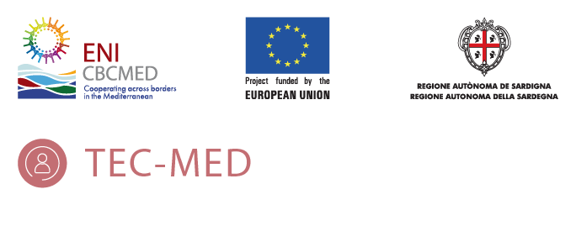

COMMUNICATION AND DISSEMINATION ACTIVITIES: INSTRUCTIONS
(JUNE 2021)

GREECE – PP4

- INTRODUCTION
The aim of this guideline is to provide partners- all partners in the project are involved in the communication WP- with handy and practical instructions on how to contribute to the communication and dissemination objectives of the TEC-MED project.
This guideline will be very helpful to the monthly communication tasks every partner of the consortium will have to do. In order to ensure the highest effectively of this activity the LB and the WP2 leader (PP1) will be always available to help to the partners with the tasks required.
This document is in line with the TEC-MED communication plan and is according to the ENI CBC MED Programme – Indicative Information and Communication Plan 2016- and the Project Implementation Manual (PIM), section 10: Communication and Visibility.
The tasks required in this guideline are based on the following instructions:
- Develop relevant content taking into account the goals of the communication plan.
- Contribute monthly with interested information about the project and its results.
- Help the LB and the WP2 leader (PP1) to promote the project using the skills and the tools necessary to achieve the communication and dissemination objectives.

This guideline includes a Communication and Dissemination Activities Template (CDAT) as a practical and useful tool which it will be used in our communication monthly job. The CDAT have been developed by the LB and PP1 –as specific leader of the communication WP- in order to facilitate and improve a bidirectional channel between the consortium and the LB. This template follows the procedure -control chain- to govern the different communication activities indicated in the communication plan.
The CDAT will be completed every month and sent – during last week of the month (deadline last day of the month)-for each partner to the LB and PP1. The information sent will be reviewed by the communication team and planned to be published in the coming months.
What kind of subjects will be requested to be included in the CDAT (or subjects suggested by every partner)?
- About the actuality of the project.
- About research, papers, informs that are being developed in the project and can be published.
- About news related to the project and can be interesting for the general and specific audiences.
- About experiences, human stories related to or linked with the project.
- About activities where the partners participate directly (congress, meeting…) related to the project and its results.
- About initiatives or activities which the partners are in collaboration with and related to the project.
What kind of information needs to be sent in the CDAT?
- Relevant content coming from the partners to update the TEC-MED website and the social media channels, such as interviews, articles.
- Visual: pictures, video, infographic images… all kind of visual content to accompany the information.
- Information developed by the partners or by official fonts (Always indicate the author of the information and the author of the visual content).
The contents will be sent to the LB and the communication package leader in the following formats: articles in Word or editable document, Photographs in jpg, Interviews in .MP4 format.
The activities developed will contribute to the effective communication of the project and its results. These activities will continue throughout all the entire lifetime of the project.
SUMMARY OF GENERAL INSTRUCTIONS TO BE FOLLOWED
- The contents that the partners must prepare, write and elaborate will be proposed by the LB and the WP2 leader at the beginning of each month (first week).
- The partners will send all the required information at the end of each month, the deadline being the last day of the month.
- All content submitted must be in English and accompanied by photographs if required (at least one or two photographs) of their own or banks of free photographs without copyright, in the case of articles.
- This communication activity –publication of contents on website and on social medial channels- will continue throughout all the entire lifetime of the project.
- Partners can contribute a SUGGESTED CONTENT, but in no case it will replace the rest of the required activities.

REQUIREMENT (1): ARTICLE ABOUT THE CAPACITY BUILDING PLAN.

- Objective: will be in charge of elaborating an article about the capacity building plan.

The TECMED Project “Development of a transcultural social-ethical-care model for dependent populations in the Mediterranean Sea basin” (A_A.3.2_0376 TECMED ENI CBC MED-Europe), is an innovative model of intercultural social care aimed at a specific age group.
The program refers to Elderly 65+ that face threat of social exclusion.
The principle objective is the evolution and the upgrade oh the existing social care units in collaboration with public administrations and agencies involved in the protection and support of this age group, in order to achieve a higher quality of social services provided.
Taking the above as statement we can easily understand the need of the existence of an organized and well structured Community Capacity Building Plan for each country participant.
“Community capacity building is the continuous process required to foster the pride and appropriate local leadership that allows communities, through their members, to take responsibility for their own development (Human Resources and Skills Development Canada quoted in Verity, 2007, p. 14, emphasis added)”.
Apart from the aside needs and requirements of each country participant there is a common denominator that every country’s plan should cover. These are the 6 fundamental dimensions of great importance and defined as below:
- Subject of care:
- Health and social providers
- Care environment and service delivery
- Governance
- Financing
- Technology

Additional to that it seems also crucial to locate the three levels of management as the key intervention between theory and practice.
- Macro level
- Meso level
- Micro level

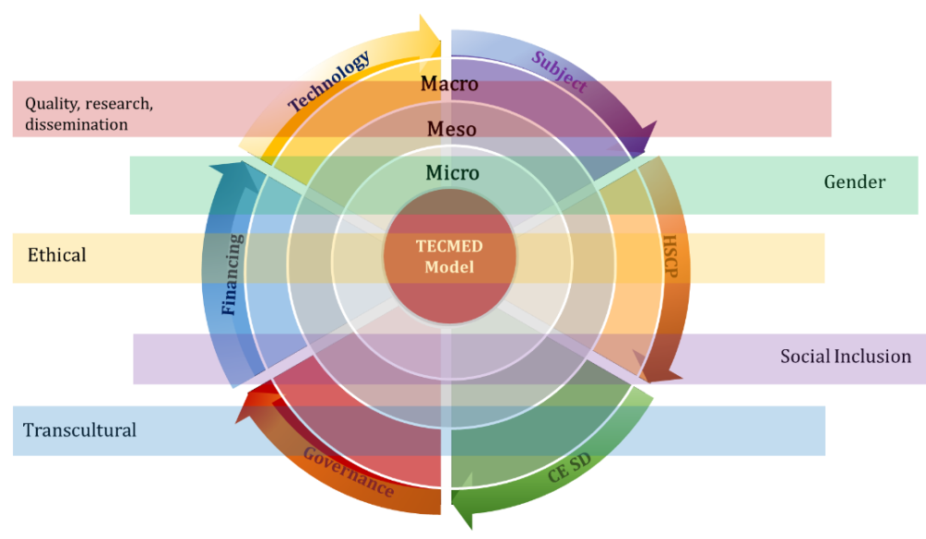
Figure 1: TECMED care model
-Dimensions (6): 1. Subject of care, 2. Health and social providers, 3. Care environment and service delivery, 4. Governance, 5. Financing, 6. Technology
- Levels of management (3): Macro, Meso, Micro

OBJECTIVES OF PP4 CAPACITY BUILDING PLAN
The initial and central principle/objective is for the communities to be empowered.
Apart from the main goal there are various aside needs that need to be covered. Below we refer the most important as far as the capacity building of Greece is concerned.
- Empowering elderly facing social exclusion
- Empowering families (caregivers) through detailed training, remuneration as a means of reward and care enhancement
- Research and recording of new emerging needs
- Promoting multi and interdisciplinary teams that include health and social professional and caregivers
- Acting against exclusion, neglecting and abuse
- Raining awareness over the importance of the funding and financial facilities
- Promoting the implementation of technology and digital social intervention
- Promoting inclusion and social justice through active participation

METHODOLOGY AND TOOLS

For each Community Capacity Dimension that highlighted above, PP4 has oriented specific areas of action, involved groups, timeline, indicators, timeline and responsible working team in order to achieve an accurate and detailed plan.
Being more specific the exact categories that we plan to cover are the following:
- Community Capacity Dimension
- Description of the objective
- Methodology/activities
- Target group
- Indicators
- Timeline and
- Work team responsible
Having approach the Community Capacity Building plan from various aspects we may focus on next steps in order to stay as close as we can to the initial plan.
Throughout the whole procedure we have the responsibility to record emerging needs that the Covid-19 pandemic had cause and to be flexible to find different options/solutions whenever required.

REQUIREMENT (3): INFORM ABOUT INTERNATIONAL WORKSHOP.

- Objective: Inform on Greece’s social networks about the next International Workshop that we will celebrate in July

The TECMED project holds webinars and Workshop in order to inform participants, stakeholders and community for the advantages of the project and the evolution in social care for the elderly.
In an effort to raise awareness, TECMED project is going to hold the 2nd International Workshop on Friday 16th of July 2021. The workshop will be online and its objective is to inform participants on “Advances and capitalization plan”.

All the relevant information on the upcoming event are presented below in the appropriate links concerning social media of PP4 (Greece)
INSTAGRAM
https://www.instagram.com/p/CRGeKtujn4D/?utm_source=ig_web_copy_link
MERIMNA OFFICIAL WEBSITE
https://merimna-patras.gr/2ο-workshop-tecmed-16-07-2021
FACEBOOK
https://www.facebook.com/Merimna.Patras.B/photos/a.1830435310355524/4442084222523940/
TWITTER
https://twitter.com/MerimnaP/status/1413425565017722880/photo/1

